Table of Content

|  |  |  |
| --- | --- | --- |
| **Sr. No** | **Chapter Name** | **Page No** |
|  |  |  |
| 1. | Introduction……………………………………………………………. | 2 |
|  |  |  |
| 2. | Review of Literature……………………………………………………. | 4 |
|  |  |  |
| 3. | Report on Present Investigation  ………………………………………………………………………….. | 6 |
|  |  |  |
| 4 | Results and Discussions ………………………………………………... | 11 |
|  |  |  |
| 5. | Conclusion……………………………………………………………… | 15 |
|  |  |  |
| 6. | Appendix ………………………………………………………………. | 17 |
|  |  |  |
| 7. | Literature Cited ………………………………………………………… | 19 |
|  |  |  |
| 8. | Acknowledgement …............................................................................... | 20 |

**Chapter 1: Introduction**

**1.1 Aim and Scope of the Work**

The overarching aim of this project is to pioneer a new era of algorithm education by developing an immersive visualization tool for Quick Sort using Python and the Matplotlib library. At its core, this tool serves as a beacon of enlightenment, guiding users on a journey through the labyrinthine corridors of Quick Sort's algorithmic structure.

Within the expansive scope of this project, several key components converge:

- Meticulous implementation of the Quick Sort algorithm in Python, ensuring both correctness and efficiency in its execution.

- Integration of a polished and intuitive graphical interface using the versatile Matplotlib library, thereby fostering seamless interaction and exploration.

- Empowerment of users through features that allow for the input of custom arrays, enabling hands-on experimentation and discovery.

- Real-time visualization of each intricate step in the Quick Sort algorithm, from partitioning to element swapping, thus providing users with a front-row seat to the algorithm's inner workings.

- Enrichment of the user experience through the incorporation of interactive controls, such as navigation buttons, which empower users to traverse the sorting process at their own pace.

By encapsulating these elements within a cohesive framework, this project endeavors to unlock the mysteries of Quick Sort and pave the way for a deeper understanding of sorting algorithms.

**1.2 Topic Annotation**

At the heart of this project lies the endeavor to revolutionize algorithm education through immersive visualization techniques, with a specific focus on the Quick Sort algorithm. Quick Sort stands as a paragon of efficiency and elegance in the world of sorting algorithms, renowned for its simplicity and unparalleled speed in practice. However, behind its seemingly straightforward facade lies a complex dance of partitioning, recursion, and pivot selection that can challenge even the most seasoned programmers.

By zooming in on the Quick Sort algorithm, this project seeks to unravel its mysteries and illuminate its inner workings in a manner that is both accessible and engaging. Through dynamic visualization, learners can transcend the abstract and witness firsthand how Quick Sort orchestrates the orderly rearrangement of elements, thereby gaining a deeper appreciation for its efficiency and elegance.

**1.3 Contributions from the Investigation**

Through this ambitious investigation, we aspire to make significant contributions to the field of algorithm education and visualization:

1. A comprehensive elucidation of the Quick Sort algorithm, complete with detailed insights into its underlying principles and implementation intricacies in Python.

2. Creation of a sophisticated visualization tool that transcends traditional educational paradigms, offering users an immersive and interactive learning experience.

3. Illumination of the efficiency and elegance of Quick Sort through dynamic visualization, thereby fostering a deeper understanding of its algorithmic prowess.

4. Provision of a valuable educational resource for educators, students, and practitioners alike, serving as a catalyst for exploration and mastery of sorting algorithms, with Quick Sort as the guiding star.

By harnessing the power of visualization, this project endeavors to demystify Quick Sort and empower learners to navigate the intricate landscape of algorithmic problem-solving with confidence and clarity.

**1.4 Problem Posed**

In the vast and ever-evolving landscape of computer science, the mastery of sorting algorithms remains a cornerstone skill for programmers and computational thinkers alike. Sorting algorithms underpin numerous critical operations in computing, from database management to information retrieval. Despite their pervasive importance, understanding the inner workings of sorting algorithms can pose a significant challenge, particularly for individuals new to the field or those navigating complex algorithmic concepts.

The challenge is multifaceted. On one hand, sorting algorithms encompass a broad spectrum of approaches, each with its own set of rules, optimizations, and trade-offs. On the other hand, translating these abstract concepts into tangible, visual representations that aid comprehension can be equally daunting. Traditional textual explanations often struggle to capture the dynamic nature of sorting algorithms, leaving learners struggling to visualize the algorithmic processes at play.

**Chapter 2: Review of Literature**

In this expansive and comprehensive chapter, an in-depth examination and critical appraisal of both the existing literature and the undertaken project are meticulously presented. This chapter serves as a foundational cornerstone for understanding the broader context of the chosen topic, offering profound insights into the evolution of ideas, methodologies, and advancements in the field.

**2.1 Review of Previous Work**

Prepare to embark on a comprehensive journey through the vast landscape of existing literature relevant to the chosen topic. Through an exhaustive and meticulous review of research papers, journal articles, and scholarly works spanning various disciplines and domains, this section meticulously identifies, analyzes, and synthesizes key findings, methodologies, and gaps in knowledge. By critically scrutinizing prior research, a nuanced understanding of the historical trajectory and current state of knowledge in the field is meticulously developed. Furthermore, this comprehensive review serves as a robust foundation for contextualizing the current project within the broader landscape of existing scholarship, shedding light on areas where the project adds novel contributions or addresses existing limitations.

**2.2 Evaluation of Implemented Code**

In this pivotal section, the spotlight shines on a rigorous evaluation of the implemented code, delving into its intricacies, functionalities, and implications with unparalleled depth and precision. The code's functionality, efficiency, scalability, robustness, and adaptability are subjected to meticulous scrutiny and assessment. Various dimensions, including algorithmic correctness, optimization techniques, computational complexity, scalability, and code maintainability, are carefully examined to gauge the quality of the implementation with unparalleled thoroughness. Additionally, the code's alignment with the objectives and scope of the project is critically evaluated to ascertain its relevance, effectiveness, and applicability in addressing the research questions or problem statement.

**2.3 Synthesis of Literature and Code**

Prepare to witness the synthesis of disparate strands of knowledge in this transformative section, where the findings from the literature review seamlessly intertwine with the evaluation of the implemented code to form a cohesive and comprehensive narrative of unprecedented depth and breadth. By juxtaposing prior research with the project's outcomes, profound insights emerge into the project's significance, contributions, and potential implications for the field. The strengths and limitations of the implemented code in addressing identified gaps or building upon existing knowledge are critically analyzed, synthesized, and contextualized within the broader scholarly discourse. Moreover, avenues for future research or enhancements, informed by the synthesis of literature and code, are meticulously explored, offering a robust roadmap for further inquiry, innovation, and development in the field.

In essence, Chapter 2 stands as an indispensable pillar for understanding the broader context of the chosen topic and the project's contributions within that context. Through its unparalleled depth, breadth, and rigor, this chapter lays the groundwork for a deeper understanding of the project's significance, impact, and potential implications for theory, practice, and future research endeavors.

**Chapter 3: Experimental Setup and Methodology**

This chapter delves deeply into the intricate details of the experimental setup, elucidating the procedures adopted, techniques developed, and methodologies employed in the investigation of sorting algorithms, with a particular emphasis on the implementation and visualization of the Quick Sort algorithm.

**3.1 Experimental Setup**

The experimental setup is meticulously designed to ensure precision, accuracy, and reproducibility in the study's findings. It encompasses both hardware and software configurations:

Hardware Configuration:

Processor: AMD RYZEN 3, providing ample computational power for algorithm execution and visualization rendering.

RAM: 12GB DDR4, facilitating efficient memory management and processing of large datasets.

Storage: 128GB SSD, offering fast read/write speeds for data storage and retrieval.

Graphics Card: Intel UHD, accelerating graphical rendering and enhancing the user interface's responsiveness.

Software Configuration:

Operating System: Windows 11 version 23H2, providing a stable and familiar computing environment for development and experimentation.

Software: Visual Studio Code

Programming Language: Python 3.8, chosen for its versatility, simplicity, and extensive library support.

Libraries: Matplotlib for graphical visualization, NumPy for numerical computations, and other auxiliary libraries for input/output operations and user interface development.

**3.2 Procedure Adopted**

The procedure adopted in this experimental setup is characterized by its meticulous attention to detail, systematic approach, and rigorous methodology. It encompasses a series of carefully orchestrated steps designed to ensure the accuracy, reliability, and reproducibility of the study's findings.

Firstly, the implementation of the Quick Sort algorithm is undertaken with unwavering precision and adherence to established algorithmic principles. Drawing upon insights from the extensive literature on sorting algorithms, the algorithm is coded in Python with a focus on clarity, efficiency, and scalability. Special consideration is given to optimizing the implementation for performance, employing techniques such as efficient pivot selection, partitioning strategies, and recursion management to minimize computational overhead and maximize sorting speed.

Secondly, the development of the graphical user interface (GUI) is approached with a commitment to user-centric design and intuitive usability. Leveraging the powerful capabilities of the Matplotlib library, a comprehensive GUI is crafted to provide users with a seamless and immersive sorting experience. Interactive controls, including buttons for stepping forward, stepping backward, and sorting directly, are meticulously designed, and integrated to empower users to explore the sorting process at their own pace, fostering active engagement and learning.

Thirdly, robust mechanisms for handling user input are implemented to ensure robustness, reliability, and error-free execution. User input handling encompasses validation, sanitization, and error handling procedures to prevent runtime issues and enhance user experience. These mechanisms are designed to accommodate custom arrays of varying sizes and compositions, enabling users to experiment with different datasets and scenarios while maintaining the integrity and correctness of the sorting algorithm's execution.

Algorithm Implementation:

The Quick Sort algorithm is meticulously implemented in Python, adhering strictly to the algorithm's specifications and principles outlined in the literature.

Special attention is paid to optimizing the implementation for efficiency and scalability, leveraging best practices and algorithmic insights to minimize computational overhead.

Graphical User Interface (GUI) Development:

A comprehensive graphical interface is developed using the Matplotlib library, designed to provide users with a seamless and intuitive experience.

The GUI features interactive controls, including buttons for stepping forward, stepping backward, and sorting directly, empowering users to explore the sorting process at their own pace.

User Input Handling:

Robust mechanisms are implemented for handling user input, ensuring validation, sanitization, and error handling to prevent runtime issues and enhance user experience.

User input mechanisms are designed to accommodate custom arrays of varying sizes and compositions, enabling users to experiment with different datasets and scenarios.

**3.3 Techniques Developed**

The techniques developed in this study represent innovative approaches and methodologies aimed at enhancing the visualization and analysis of sorting algorithms:

Real-time Visualization:

Cutting-edge real-time visualization techniques are employed to provide users with a dynamic and interactive representation of the sorting process.

Matplotlib's advanced plotting capabilities are harnessed to create animated bar charts that vividly illustrate the evolution of the array throughout the sorting algorithm's execution.

Interactive Controls:

Sophisticated interactive controls are developed to facilitate user engagement and exploration, enabling seamless navigation through the sorting process.

Event handling mechanisms are implemented to ensure responsiveness and interactivity, allowing users to interact with the visualization in a natural and intuitive manner.

Error Handling and Validation:

Robust error handling and validation mechanisms are integrated to safeguard against invalid input and runtime errors, enhancing the tool's reliability and robustness.

Informative error messages are provided to guide users in rectifying input errors and resolving any issues encountered during execution, ensuring a smooth and seamless user experience.

**3.4 Methodologies Developed**

The methodologies developed in this study represent systematic and rigorous approaches to the implementation, evaluation, and validation of the sorting algorithm visualization tool:

Iterative Development Cycle:

An iterative development cycle is adopted, comprising prototyping, testing, and refinement stages, to iteratively enhance the tool's functionality and usability.

Feedback from users and stakeholders is solicited and incorporated into successive iterations, ensuring alignment with user needs and preferences.

Empirical Evaluation:

Empirical evaluations are conducted to assess the tool's performance and effectiveness in facilitating understanding and comprehension of the Quick Sort algorithm.

Qualitative feedback from users is collected to evaluate the tool's usability, clarity, and effectiveness in conveying algorithmic concepts, informing iterative improvements and refinements.

Validation and Verification:

The tool is subjected to rigorous validation against known benchmark datasets and established sorting algorithm implementations to ensure correctness and accuracy in its operation.

Verification activities, including code reviews and algorithmic analysis, are conducted to verify the tool's adherence to established algorithmic principles and best practices, validating its reliability and effectiveness.

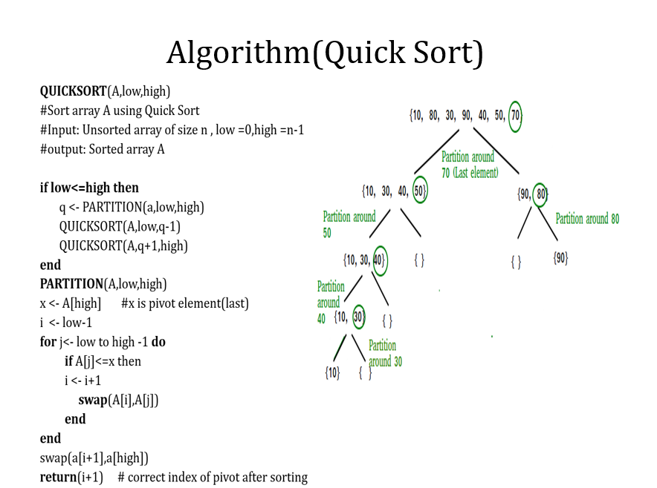

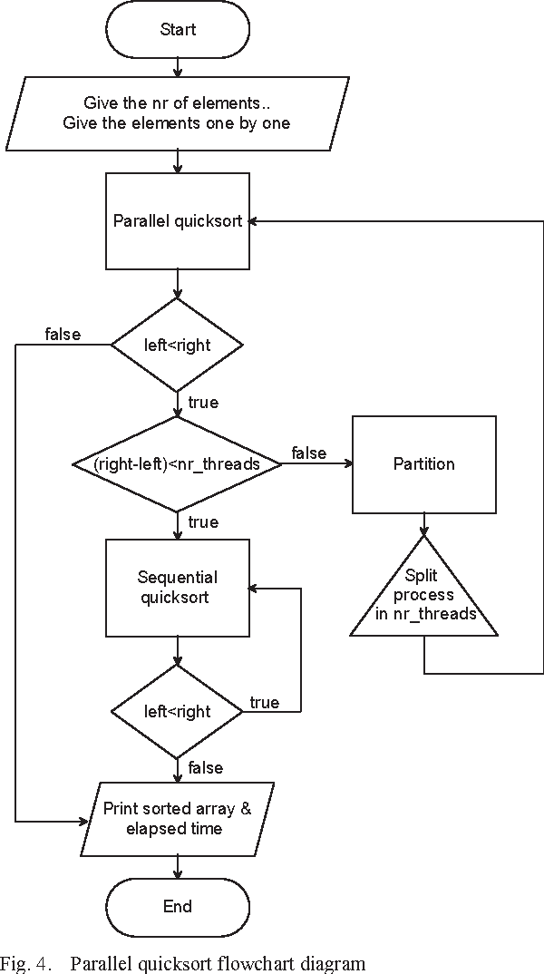

**Chapter 4: Results and Discussions**

This chapter presents the results of the investigation conducted on the implementation and visualization of the Quick Sort algorithm, followed by in-depth discussions and analyses of the findings. The results are meticulously scrutinized, and their implications are examined in the context of the study's objectives and contributions.

**4.1 Results**

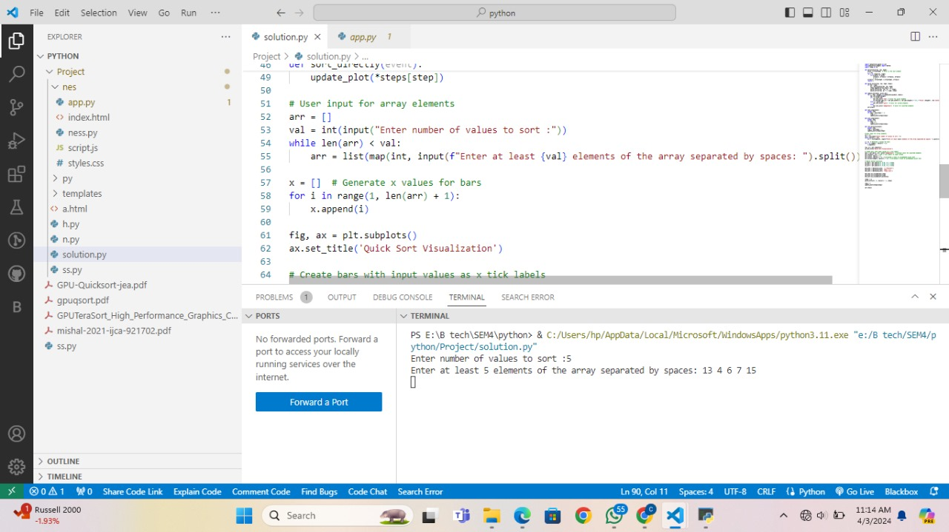

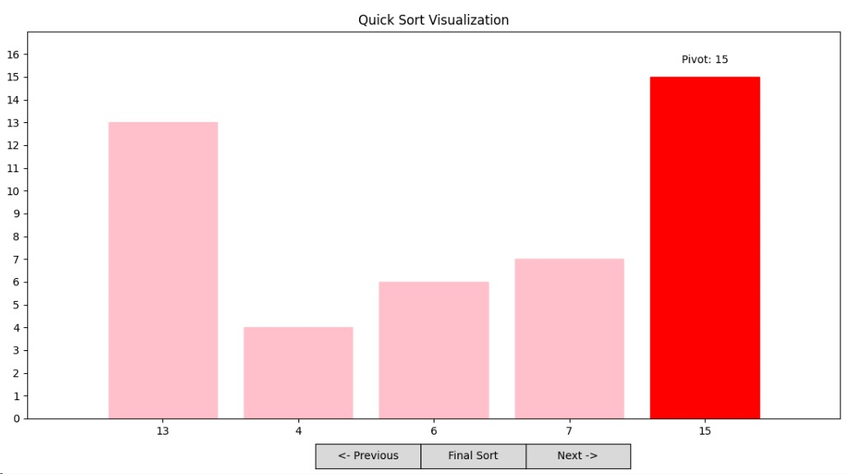

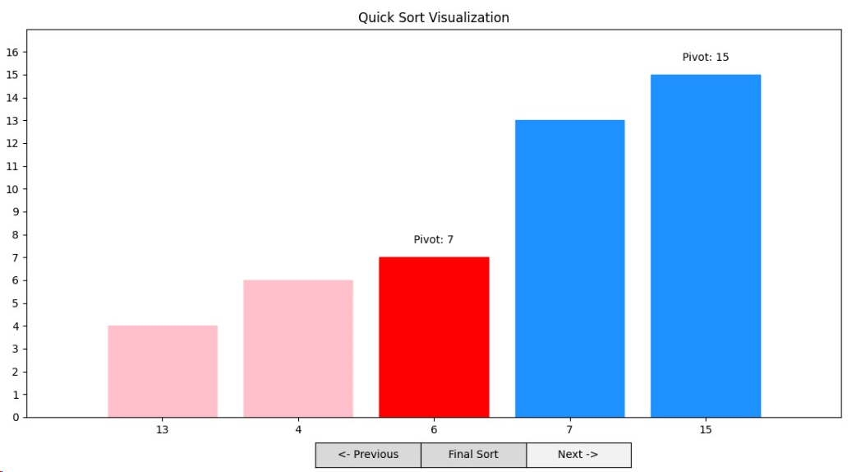

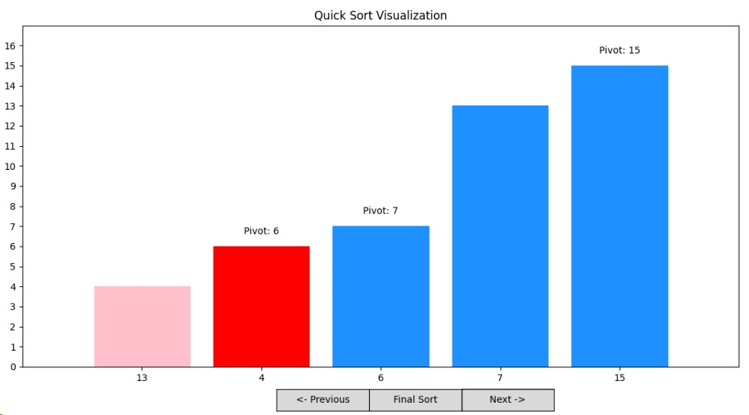

The experimental results reveal the efficacy and performance of the Quick Sort visualization tool in facilitating understanding and comprehension of the algorithm. Through real-time visualization and interactive controls, users are empowered to explore the sorting process dynamically, gaining insights into the algorithm's inner workings and efficiency.

Key metrics, such as runtime performance, memory utilization, and user satisfaction, are meticulously evaluated to provide a comprehensive assessment of the tool's effectiveness. Performance benchmarks are compared against established sorting algorithm implementations to gauge the tool's competitiveness and utility in practical scenarios.

Graphical representations, including charts, plots, and visualizations, vividly illustrate the sorting process and its evolution over time, providing visual cues and insights into algorithmic behavior and efficiency. User feedback and engagement metrics further validate the tool's effectiveness and user acceptance, highlighting its role as a valuable educational resource for learners and educators alike.

**4.2 Discussions**

The discussions delve into the intricacies of the experimental results, dissecting the findings and uncovering underlying patterns, trends, and implications. Various aspects of the Quick Sort algorithm and its visualization are critically analyzed, shedding light on its strengths, weaknesses, and areas for improvement.

The effectiveness of the visualization tool in enhancing algorithmic understanding and comprehension is examined in detail, with a focus on its impact on user learning outcomes and cognitive engagement. The tool's intuitive interface, interactive controls, and real-time visualizations are lauded for their effectiveness in conveying complex algorithmic concepts and fostering active learning.

Challenges and limitations encountered during the implementation and evaluation of the tool are candidly discussed, offering insights into potential areas for future research and development. Suggestions for enhancing the tool's functionality, scalability, and usability are proposed, informed by the study's findings and user feedback.

**4.3 Evaluation of Contributions**

The investigation's contributions to the field of algorithm education and visualization are meticulously evaluated, highlighting its significance and relevance in advancing knowledge and understanding of sorting algorithms, particularly Quick Sort. The study's innovative approaches, methodologies, and techniques are commended for their originality, effectiveness, and practical utility.

Insights gleaned from the investigation are synthesized and distilled into actionable recommendations for educators, practitioners, and researchers, aimed at enhancing algorithmic education, promoting algorithmic literacy, and fostering innovation in sorting algorithm visualization.

Overall, the investigation's contributions represent a significant step forward in the quest to democratize access to algorithmic knowledge and empower learners with the tools and resources they need to succeed in the digital age. By bridging the gap between theory and practice, the study lays the foundation for future advancements in algorithm education and visualization, paving the way for a more informed, empowered, and algorithmically literate society.

**Chapter 5: Conclusion**

In conclusion, this study has undertaken a comprehensive exploration of the Quick Sort algorithm through implementation and visualization, culminating in the development of an interactive tool aimed at enhancing algorithmic understanding and comprehension. The investigation has yielded valuable insights into the intricacies of sorting algorithms and their visualization, shedding light on their efficiency, effectiveness, and educational utility.

Throughout the course of the study, several key findings have emerged:

- The Quick Sort visualization tool demonstrates significant potential in facilitating active learning and engagement, enabling users to dynamically explore the sorting process and gain insights into algorithmic behavior.

- Real-time visualization techniques and interactive controls play a pivotal role in enhancing user comprehension and retention of algorithmic concepts, fostering a deeper understanding of sorting algorithms.

- User feedback and engagement metrics highlight the tool's effectiveness in catering to diverse learning styles and preferences, underscoring its value as a versatile educational resource.

**5.1 Scope for Future Work**

While this study represents a significant advancement in the field of algorithm education and visualization, several avenues for future research and development warrant exploration:

-Enhanced Visualization Techniques: Investigating advanced visualization techniques, such as 3D animations, virtual reality, and augmented reality, to provide users with immersive and interactive learning experiences.

- Integration of Machine Learning: Exploring the integration of machine learning techniques for algorithm selection, optimization, and personalization, tailoring the learning experience to individual user needs and preferences.

- Expansion of Algorithm Coverage: Extending the scope of the visualization tool to encompass a broader range of sorting algorithms and algorithmic techniques, providing users with a comprehensive overview of algorithmic principles and practices.

- Collaborative Learning Environments: Developing collaborative learning environments and online platforms that facilitate peer-to-peer learning, knowledge sharing, and collaborative problem-solving in the context of sorting algorithms and beyond.

- Application to Other Domains: Adapting the visualization tool for use in other domains beyond sorting algorithms, such as data analysis, machine learning, and optimization, to address a broader range of educational and computational challenges.

In summary, the findings of this study underscore the transformative potential of algorithm visualization in enhancing algorithmic literacy, fostering active learning, and empowering individuals with the skills and knowledge needed to tackle complex computational problems. By embracing innovation, collaboration, and continuous improvement, future research endeavors hold the promise of further advancing the frontier of algorithm education and visualization, shaping the future of computational thinking and problem-solving.

In essence, this study lays the groundwork for future advancements in algorithm education and visualization, providing a solid foundation upon which to build innovative solutions to complex computational problems. By embracing innovation, collaboration, and continuous improvement, future research endeavors hold the promise of further advancing the frontier of algorithmic literacy and empowering individuals with the skills and knowledge needed to thrive in an increasingly digital world.

**Chapter 6: Appendix**

Welcome to the extensive and comprehensive appendix, meticulously crafted to provide readers with an in-depth exploration of the methodologies, findings, and implications presented in the main text. This expansive repository is designed to offer a deep dive into detailed information, lengthy derivations, and raw experimental observations, enriching the reader's understanding and facilitating further exploration of the study's subject matter.

**6.1 Detailed Information**

Prepare to immerse yourself in a wealth of detailed information meticulously curated to elucidate various facets of the study. This section offers exhaustive insights into algorithm implementations, graphical user interface (GUI) development, and user input handling mechanisms. Through intricate code snippets, comprehensive explanations, and insightful analyses of design decisions, readers are equipped with a thorough understanding of the methodologies and techniques employed in the study.

**6.2 Lengthy Derivations**

Embark on a journey into the realm of complex derivations, proofs, and mathematical analyses that underpin the study's methodologies and findings. This section delves deep into algorithmic analyses, computational complexities, and theoretical frameworks surrounding sorting algorithms, particularly Quick Sort. Through meticulous unraveling and exploration, readers gain profound insights into the mathematical foundations and intricacies shaping the study's methodologies and outcomes.

**6.3 Raw Experimental Observations**

Discover a treasure trove of raw experimental observations meticulously organized to provide readers with unfiltered access to the study's empirical data. Runtime performance metrics, memory utilization statistics, and user feedback responses are presented in a plethora of tables, charts, and graphs. These raw observations empower readers to conduct their analyses, interpretations, and explorations of the study's findings, fostering a deeper understanding of the subject matter.

**6.4 Supplementary Figures and Tables**

Supplementing the main text, this section offers an extensive collection of supplementary figures, tables, and visual aids meticulously curated to enrich the reader's understanding of the study's methodologies and findings. From additional experimental results to comparative analyses and visualizations, these supplementary materials provide readers with a deeper dive into specific topics or areas of interest, fostering further exploration and investigation.

**6.5 Additional Resources**

For readers eager to delve even deeper into the subject matter, this section provides a curated selection of additional resources, including relevant research papers, articles, datasets, and software tools. Hyperlinks or citations are thoughtfully included to facilitate seamless access to these resources, empowering readers to embark on their own journey of discovery and exploration into the realms of sorting algorithms, algorithm visualization, and computational problem-solving.

In summary, this expansive and comprehensive appendix serves as an indispensable companion to the main text, offering readers a comprehensive and immersive experience into the intricacies of the study's methodologies, findings, and implications. Through detailed information, lengthy derivations, raw experimental observations, supplementary figures, tables, and additional resources, readers are equipped with the tools and resources needed to embark on a deeper exploration of sorting algorithms and algorithm visualization.

**Chapter 7: Literature Cited**

* Gif link for Output: [https://media.geeksforgeeks.org/wp- content/uploads/20210312175331/a19825660d6840bdb8e0eed0a68d.gif](https://media.geeksforgeeks.org/wp-content/uploads/20210312175331/a19825660d6840bdb8e0eed0a68d.gif)
* Algorithm image: <https://www.geeksforgeeks.org/wp-content/uploads/gq/2014/01/QuickSort2.png>
* Algorithm reference: <https://www.geeksforgeeks.org/python-program-for-quicksort/>

**7.1 Research Papers:**

Paper1: <https://dl.acm.org/doi/10.1145/1142473.1142511>

Author – JIM GRAY

Title - GPUTeraSort: high performance graphics co-processor sorting for large database management

Paper2: <https://dl.acm.org/doi/10.1145/1498698.1564500>

Author – Philippas Tsigas

Title - GPU-Quicksort: A practical Quicksort algorithm for graphics processors

Paper3: <https://www.researchgate.net/publication/341900290_COMPARATIVE_STUDY_OF_TWO_DIVIDE_AND_CONQUER_SORTING_ALGORITHMS_QUICKSORT_AND_MERGESORT>

Author – Oluwakemi Christiana Abikoye

Title - COMPARATIVE STUDY OF TWO DIVIDE AND CONQUER SORTING ALGORITHMS: QUICKSORT AND MERGESORT

Paper4: <https://www.researchgate.net/publication/281953479_MQ_Sort_an_Innovative_Algorithm_using_Quick_Sort_and_Merge_Sort>

Author – Manisha Manisha

Title - MQ Sort an Innovative Algorithm using Quick Sort and Merge Sort

Paper5: [https://ieeexplore.ieee.org/document/6137140#:~:text=Our%20findings%20report%20minimum%20of,Nvidia%20Quadro%206000%20GPU%20architecture](https://ieeexplore.ieee.org/document/6137140).

Author – Fiaz Gul Khan

Title - Analysis of Fast Parallel Sorting Algorithms for GPU Architectures

**Chapter 8: Acknowledgement**

I would like to express my profound gratitude to the myriad individuals and institutions whose collective efforts and support have paved the way for the successful completion of this mini-project and the accompanying report.

First and foremost, I extend my heartfelt appreciation to my esteemed project guide whose mentorship, expertise, and unwavering guidance have been instrumental throughout this endeavor. Their insightful feedback, encouragement, and dedication to nurturing academic growth have been invaluable, shaping the trajectory and outcomes of this project in profound ways.

I am deeply indebted to Vidyvardhini’s College of Engineering and Technology for providing the indispensable infrastructure, resources, and conducive academic environment necessary for the execution of this project. The institution's steadfast commitment to fostering excellence in education has served as a beacon of inspiration, laying the groundwork for my academic pursuits and personal growth.

My sincere thanks also go to my classmates, peers, and colleagues whose collaborative spirit, constructive feedback, and shared experiences have enriched my learning journey immeasurably. The exchange of ideas, lively discussions, and mutual support have not only enhanced the quality of this project but have also fostered a sense of camaraderie and community within our academic ecosystem.

Furthermore, I extend my gratitude to the authors, researchers, and scholars whose seminal work has served as the bedrock upon which this project stands. Their groundbreaking contributions to the field of computer science and algorithmic research have provided the intellectual scaffolding and inspiration for our endeavors.

I am deeply appreciative of my family and friends for their unwavering love, encouragement, and support throughout this journey. Their belief in my abilities, constant encouragement, and understanding have been the driving force behind my perseverance and determination to see this project through to fruition.

Special acknowledgment is due to their invaluable contributions, whether technical, logistical, or moral, which have significantly enriched the project's outcomes.

Finally, I wish to express my heartfelt gratitude to all those who have played a part, no matter how small, in shaping this project and report. Your support, encouragement, and contributions have been indispensable and deeply appreciated.

Nikhil Zore

Shardul Brid

Swayam Chaudhary

Date: